1. Initialize Git repository:



1. Get status of Git repository:

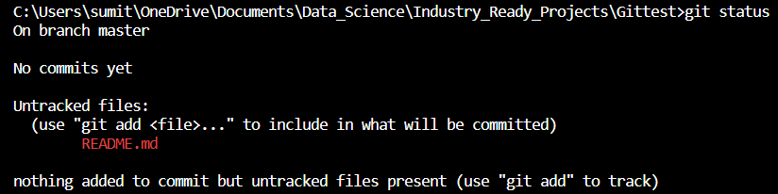

1. Check the main branch name:



1. Change the name of the main branch to “main”:



1. Track the changed file, changes get written to staging area:



1. Commit the changes i.e. permanently store the changes



1. Add a remote repository:



1. Push the files to the remote repository:

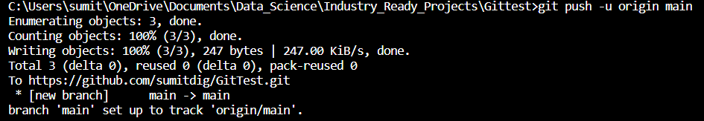

1. View project history:

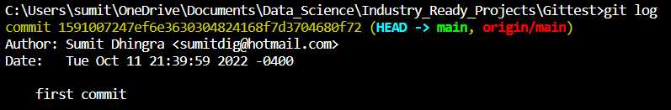

1. List the overview of changes:

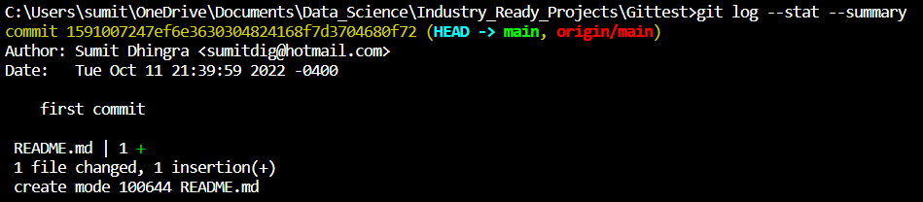

1. Create a new branch “developer1”:



1. Switch to developer1 branch:

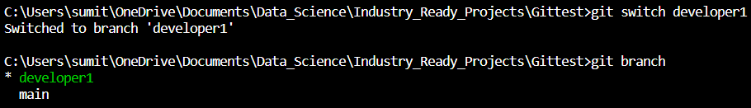

1. Merge changes made by Developer1:

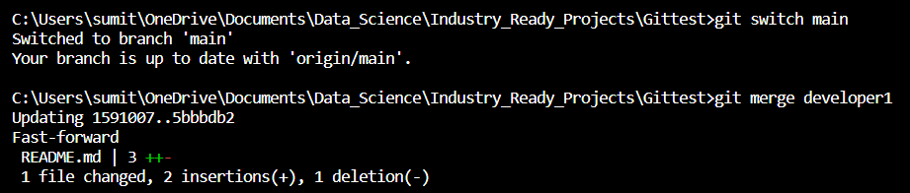

1. See the commit history using graph representation:

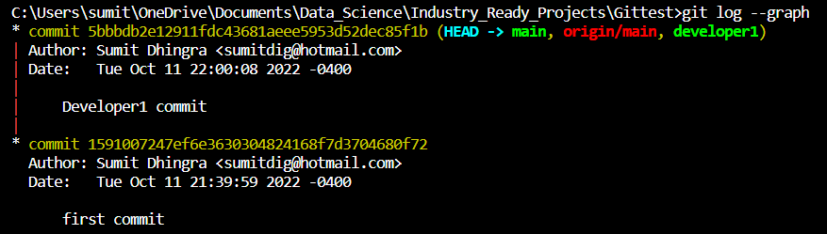

1. Delete branch developer1:

